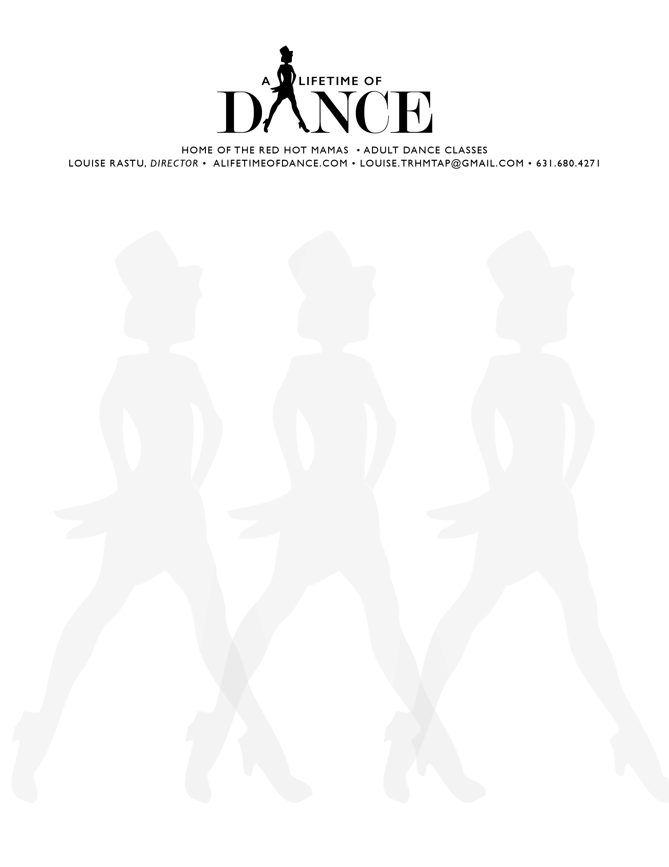

# RELEASE OF LIABILITY

**READ CAREFULLY-THIS AFFECTS YOUR LEGAL RIGHTS**

**In exchange for participation in the activities of A LIFETIME OF DANCE, INC. organized by LOUISE RASTU of Lindenhurst, New York and or/use of the facilities and programs of said A LIFETIME OF DANCE, INC., I agree for myself and for my Estate to the following:**

**1. I agree to observe and obey all rules and further agree to follow any oral instructions and directions given by Louise Rastu or her representatives or agents.**

**2. I recognize that there are certain inherent risks associated with the above described activities and I assume full responsibility for any personal injury to myself and further release and discharge Louise Rastu, individually and collectively doing business as A LIFETIME OF DANCE, INC., for any injury, loss or damage arising out of my participation in any of the classes, rehearsals or performances by A LIFETIME OF DANCE, INC., caused by my sole negligence.**

**3. I agree to indemnify Louise Rastu, individually and collectively doing business as A LIFETIME OF DANCE, INC., against all finally awarded third party claims, causes of action, damages, judgments, costs and expenses including reasonable attorney’s fees or other litigation costs, arising from any loss resulting from my acts or omissions, but only to the proportional extent arising out of my negligence, from my use of or presence upon the facilities used for classes, rehearsals or performances.**

4. In exchange for consideration received, I hereby give permission to Louise Rastu and A Lifetime of Dance, Inc. to use my name and photographic likeness in all forms and media for advertising, trade and any other lawful purpose.

**I HAVE READ THIS DOCUMENT AND UNDERSTAND THAT BY SIGNING THIS RELEASE I VOLUNTARILY SURRENDER CERTAIN LEGAL RIGHTS.**

**NAME: ________________________________________________ Date_______________________**

**SIGNATURE: ____________________________________________________________________________________**